**Geographic Distribution of Equipment**

At various points, every state took advantage of the 1033 program (some more than others). Some counties stood out in particular (e.g. some in California, Texas, and Florida) for their avid use of the program. The highest density of counties using the program was in the mid-west and the south. The redistribution of military equipment briefly peaked in 2006 and then declined until 2010 when it began a steady incline through 2013.

**Type of Equipment Received**

Guns

Ammunition

Explosives

**Summary of Findings**

There was a demonstrable increase in police fatalities from 2000 to 2016, culminating in a massive spike in 2015.

The 1033 program is widely used nationwide (both by quantity and capital) and significantly increased in usage from 2010 to 2014. Additionally, there is a huge variation of types of equipment which obfuscates the research question.

**Implications of Findings**

The results we see in our datasets show similar trends in what we see represented in the news today; greater police and civilian deaths; unfair treatment of minorities and a more militarized police force.

We cannot draw conclusive judgements on the correlations, but there is enough of a correlation to warrant further investigations.

**Possible Relationship Between 1033 and Deaths**

It’s not clear from our analysis that there is a relationship. In particular, we see a rise in use of the program from 2010 forward, and similarly a rise in police fatalities from 2000 to 2016, increasing in its velocity in 2011. However, given the number of variables we did not consider, we cannot claim with confidence that there is a correlation.

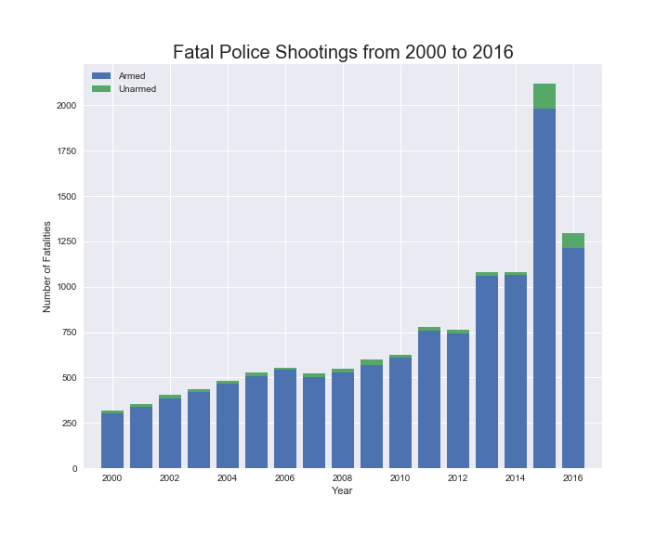

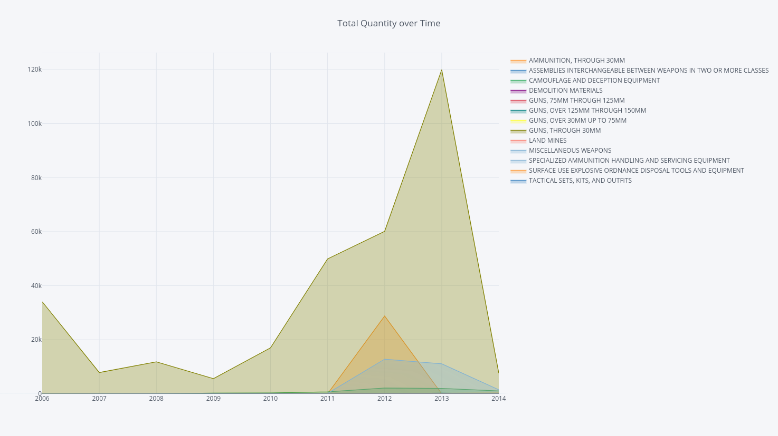

**GDP and 1033**

There was no apparent correlation between GDP and 1033. We can just say as GDP was rising so was the 1033 usage. States with the highest GDPs did not seem to have more or less 1033 usage.

